**Packet Capture Analysis:**

I have analysed the provided packet capture file using the free network analysis tool Wireshark.   
I was able to put “http” into the filter field in order to filter the network traffic to only see HTTP packets.   
  
This view let me see some interesting http GET requests, which indicate that the user specifically requests information, including one for hackers.jpg

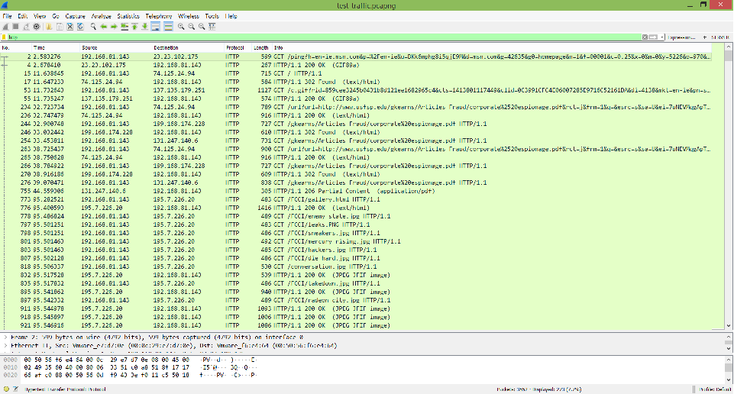

To investigate this image download further, I viewed its TCP stream to see what I could find.  
Looking through the data in the TCP stream showed that this get request actually downloaded two images, as the data contained two headers and two footers for a .jpg image. The header/footer is FFD8 – FFD9 in hex and the images are also recognizeable in ASCII by the string ‘JFIF’ near the start.  
The ASCII view shows that the second image is called Radeon_city.jpg.

The next step taken was carving out the images from the tcp stream, which I did by taking all the hex from FFD8 to FFD9 and copying it into the hex editor program HxD. I then saved the file as a jpg and opened it, resulting in the image below.   
  


I followed the same process for the second image.

